CS 415

HW1 Report

Lena.png:

Mean filter:

Kernel size 3: Kernel size 5: Kernel size 7:

Gaussian filter:

Kernel size 3: Kernel size 5: Kernel size 7:

Sharpen filter:

Kernel size 3: Kernel size 5: Kernel size 7:

Art.png:

Mean filter:

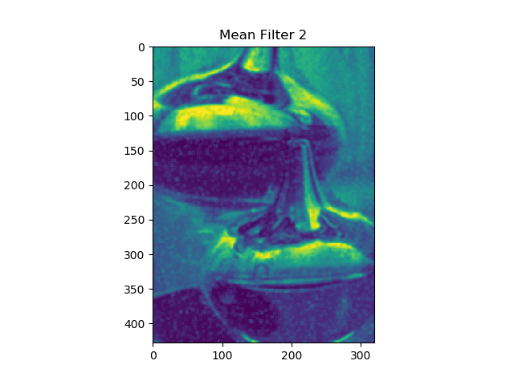Kernel size 3: Kernel size 5: Kernel size 7:

Mean filter corrleation:

Kernel size 3: Kernel size 5: Kernel size 7:

Median filter:

Kernel size 3: Kernel size 5: Kernel size 7:

The algorithm of convolution function is to flip the kernel vertically and horizontally, and then get the area of the neighborhoods, and then apply the kernel along the pixels in the image. The difference between cross-correlation and convolution is that correlation is not needed to be flipped. The Gaussian kernel function is just implement the formular with a given sigma. Sharpen filter is to underscore the centre of kernel, and apply it to image. Median filter is to store the values in the kernel, and replace the centre with median.

Problem left is why the input image is gray scale but the output is sort of green.

As we can see from the pictures, for the same kernel size, Gaussian filter seems like has a better effect than mean filter. Also, I think that the size of the kernel size does not affect the quanlity of sharpening image that much. And when I tried to remove noise from the image, obviously, median filter did the best, and the mean filter, no matter from convolution or cross correlation, is worse.